The Hills Have Towers

*Created by:*

Nicholas MacDonald

Keenan Johnston

Pierre Chen

Pavel Szczesny

**Version**

version 1.00: July 11th, 2012

* First time design document was declared “complete”

version 1.01: September 6th 2012

* Added the Version section itself
* Finalized the name (no objections so hey, why not)
* Ported all pre-document notes over to the document “483 project” which will serve as a temporary repository for extra notes on this project.
* Removed “Expandability” from the Game Overview section; it had no contents
* Removed any mention of projectiles from towers missing
* Added section on tower placement and tower obstruction cases.

version 1.02: September 7th 2012

* Added a section and image for ingame UI.
* Added brief section detailing controls, needs expansion.
* Began elaborating on enemy types

version 1.03: September 12th 2012

* Expanded towers section slightly.
* Redid tower stats on a 1 to 10 to give a better idea of their abilities.

version 1.04: September 13th 2012

* Removed walls/support

version 1.1: September 14th 2012

* Rewrote most sections to better describe the current state of the game, including overview, tower damage and range, upgrades, control and movement, feature set
* Added numerical values to most tower attributes, removed path slowing option, added oil tower
* Expanded and rewrote enemies section, added numerical values for some enemy attributes and retooled others, priest enemy added
* Added level design and UI images

version 1.2: November 18th 2012

* Removed the 16x16 level grid
* Added minor details to Damage Types under Towers
* Added note to enemy stats
* Elaborated on resources in the resource overview.

version 1.3: February 17th, 2013

* Added new level design and a description
* Added Torch, Tesla and Magic towers
* Added Boss description

**Game Overview**

**Philosophy**

Time and Space Management

The player’s main focus will be balancing their time between building towers and gathering resources while keeping watch of incoming enemies and being able to react accordingly. It is up to the player to decide how to make the most efficient use of their time, and to balance decisions such as the defending potential shorter paths for the enemies to travel versus the resources gained opening these paths.

Dynamic Play

The ability to harvest resources located around the map in order to construct towers gives many different options in how to approach the gameplay. One player may find themselves drawn to harvesting the rarest resources and having access to the strongest towers, but with a large risk involved in their collection. Another player, however, may play it more safe and harvest only near their base and make due with lower-tier towers in greater abundance. Taking risk will present great rewards, but players must judge for themselves whether or not they wish to make them. This is especially true for harvesting resources found on the path itself, which will open up new paths for the enemies to reach the player’s base. Whether this is used to an advantage or disadvantage is up to the player, and makes one map able to have many different viable playstyles.

**Common Questions**

What is the game?

The game is a 3D isometric tower defence game. The player gathers resources scattered around the map in order to build defences to protect their village. The player must put a lot of consideration into where they gather their resources from because as resources are harvested, new paths may be opened up due to these obstacles being removed. Harvesting also allows the player to free up spaces on the map to place towers, giving them a wider range of options and allowing them to take advantage of higher ground and other favourable areas such as on an inside corner of the path. At the end of a level, the player will be able to spend the experience they earn on small upgrades which will persist through subsequent levels.

Why create the game?

The tower defence genre seems like the most appropriate genre for our project because it provides a solid foundation with many options for expansion. Our goal is to create a fun, functional game that explores several different aspects of game development and programming such as procedural terrain generation, pathfinding algorithms, physics, particle effects and more.

Where does the game take place?

The game takes place in a medieval setting where the player, the chief protector of the village, builds towers out of wood, stone and iron to protect the citizens against the invading kingdom. Maps will contain these respective resources to be harvested, with trees, stone outcrops and veins of iron to be found. Terrain elevation is also variable, allowing a map to be either a flatter plain or a more hilly area, which has an impact on gameplay.

What do I control?

You control a soldier who has set out to defend the villages he encounters, as he travels through the world. He is controlled from an isometric view, is used to gather resources and construct towers to defeat the incoming waves of enemies. He has a physical presence on the map, and the player will need to control him in an RTS-styled fashion, ordering him to a specific point in order for him to complete a task. He has several attributes, including movement speed, tower build time and resource gathering speed which can be improved over the course of a level.

What is the main focus?

The main focus of the game is to protect your village from the incoming enemies. You need to gather resources from the field which include wood, stone and iron and then use them to build a small variety of towers. The player needs to consider several factors when building towers, including the position relative to the path, the terrain elevation, and what areas of their defense are the weakest.

Whatʼs different?

The inclusion of resource gathering through a character on the field adds another dimension to the traditional tower defense gameplay, where towers are most often selected and built through a menu at will. The player must balance their time between building and upgrading towers while also exploring the map and collecting the resources required to do so. They must use their own judgement to determine when more towers are needed and when they can continue to harvest resources, which will be a key factor in whether they will be successful on a given map or not. Additionally, the ability to open new paths for the enemies by harvesting resources located on the path allows for many different strategies for a given map, and a risk/reward element that may present the player with an abundance of resources, but give the enemies a much more direct path to the village.

What do I Need to Run the Game?

The minimum required specs to run the game will be an Intel Core i5 processor running at 2.0 GHz, 4 gigabytes of RAM and Intel HD 4000 graphics.

**Feature Set**

**General Features**

Towers

The towers featured in the game will cover all the major staples of a standard tower defense. They include a basic arrow tower, a cannon tower, a long-range arrow tower, a short-range streaming attack tower and a slowing area tower. Each has it’s own use on a map, with some towers being more effective against certain enemies than others.

Terrain Height

Towers built on high ground will receive a range bonus, allowing them to hit significantly further enemies then a tower built on the same level as the path. These spots will be invaluable to the player’s defense and relatively rare on most maps. Similarly, a tower built on low ground will have its range reduced, making it a poor decision in most cases. Low ground will generally serve as areas for resources and to discourage and/or limit the player from building there.

Resources

Resources are one of the key features of the game, allowing the player to build more advanced towers and upgrade their base towers to their maximum level. They are found on tiles located throughout the map for each round, which the player must direct their character to in order to harvest. They follow a tiered path, beginning with wood, followed by stone and finally iron. Low-tier resources are generally found in abundance closer to the player and high-tier resources found more scarcely further from the player’s base and in more compromising areas which may open new paths for the enemies to travel on. The strongest resources will be used for the best upgrades and towers and therefore require a significant time investment from the player in order to harvest them while still protecting their base.

**Gameplay**

Overview

As a tower defense game, the primary objective for the player is the construction of towers in order to defeat enemies which approach on a defined path. In this case the player will be defending a base from which enemies will retrieve an object (a villager) and attempt to flee back along the shortest path to exit the level. Should an enemy reach the bounds of the map they will disappear and the player will lose one life. In order to defend their base effectively, the player must construct a variety of towers and gather resources found on the map in order to upgrade their towers.

Interaction

Unlike many traditional tower defense games, the player will assume the role of an actual character on the map. To move their character around, the character right clicks on available tiles to move there and left clicks on them to interact. Depending on the context, this will either allow them to harvest a resource, build a tower or upgrade/sell a tower.

Level Design

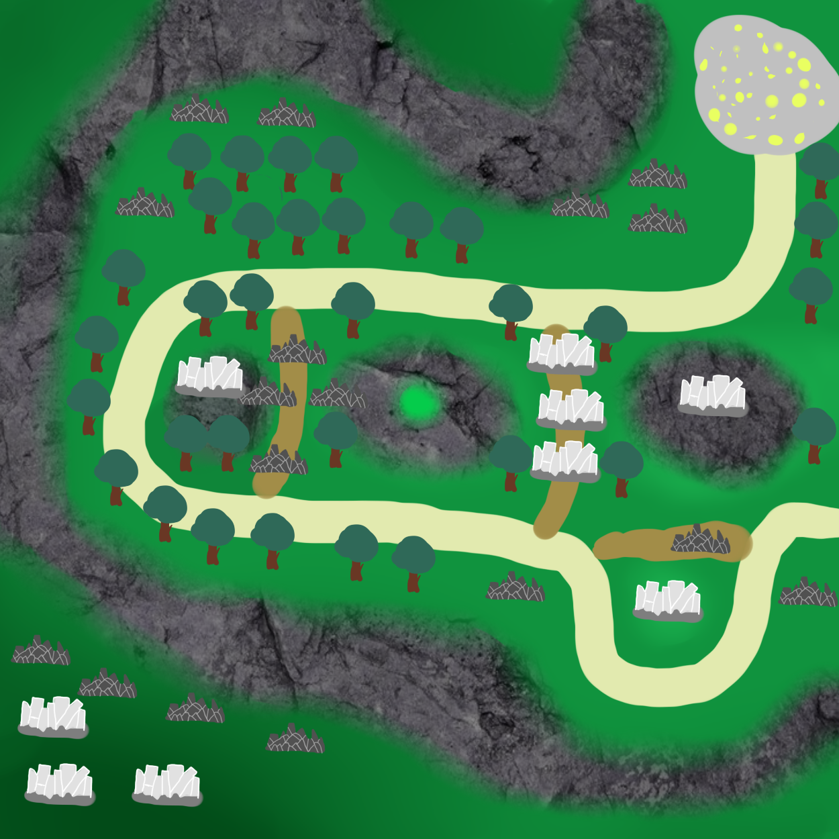

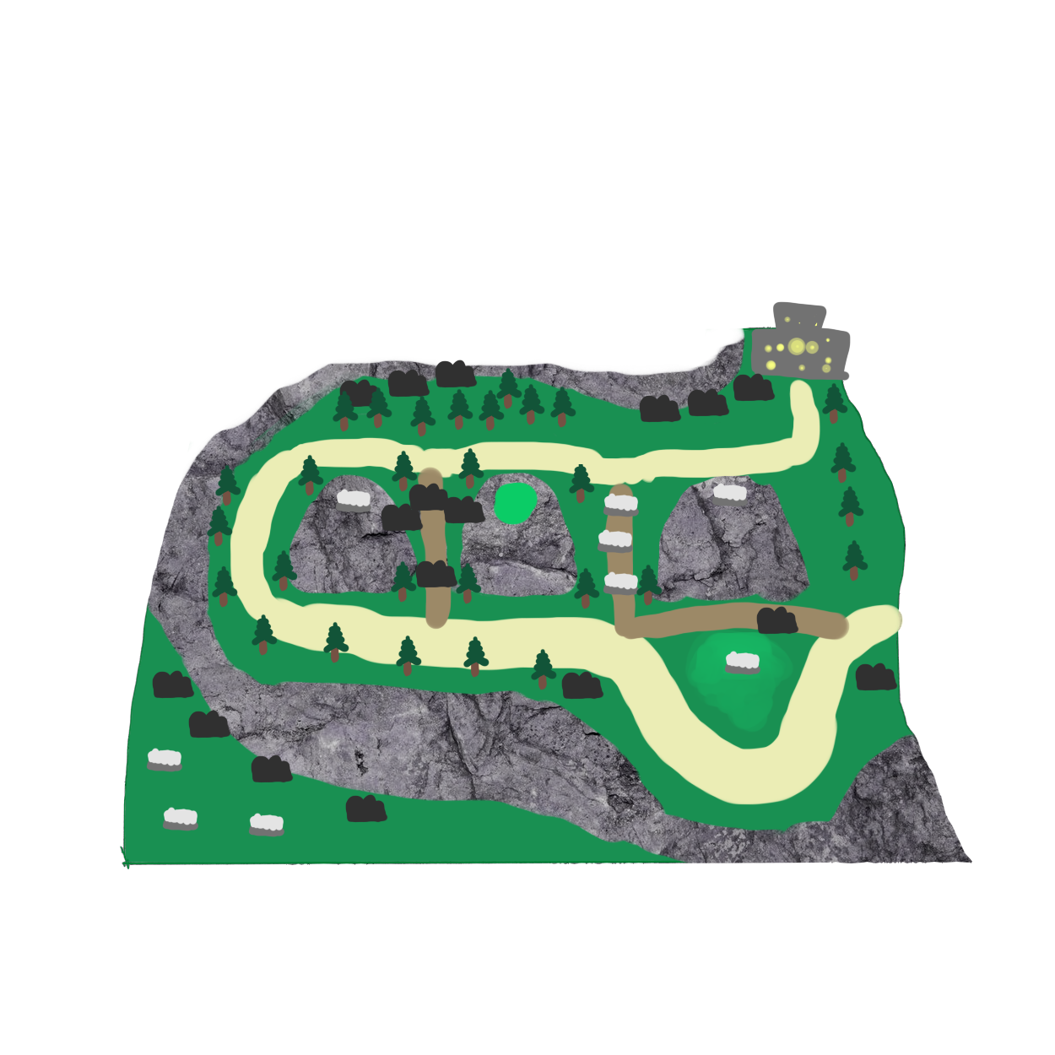This level prioritizes intelligent placement of towers over anything else. With only a few viable spots to place tower and only two ranged locations, the player needs to put the right towers in the right spots to survive. This map would also be impossible if the player decided to open both the primary paths too, so extra emphasis is put on controlling the enemy route.

Note: All rocky walls in this level are climbable.

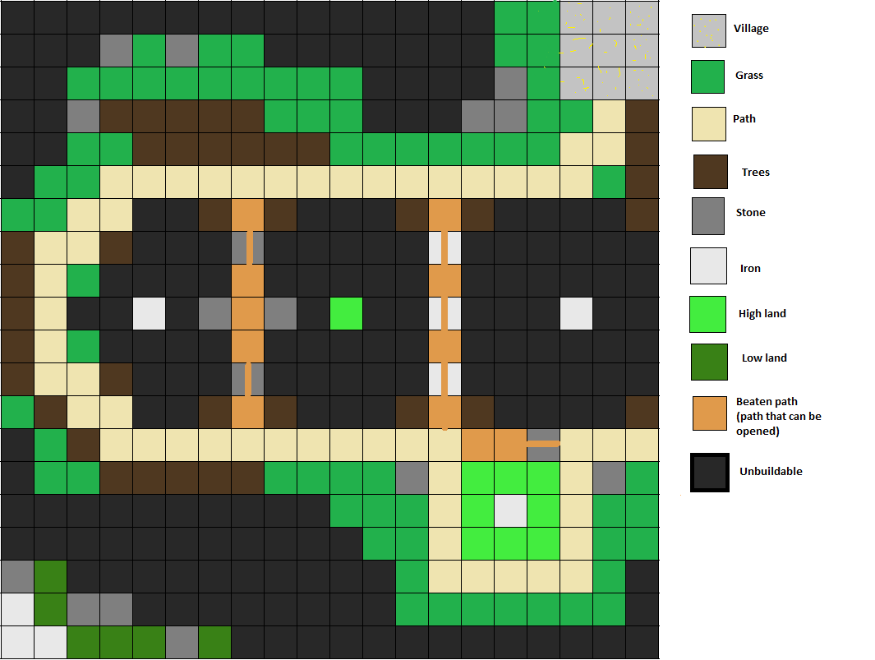

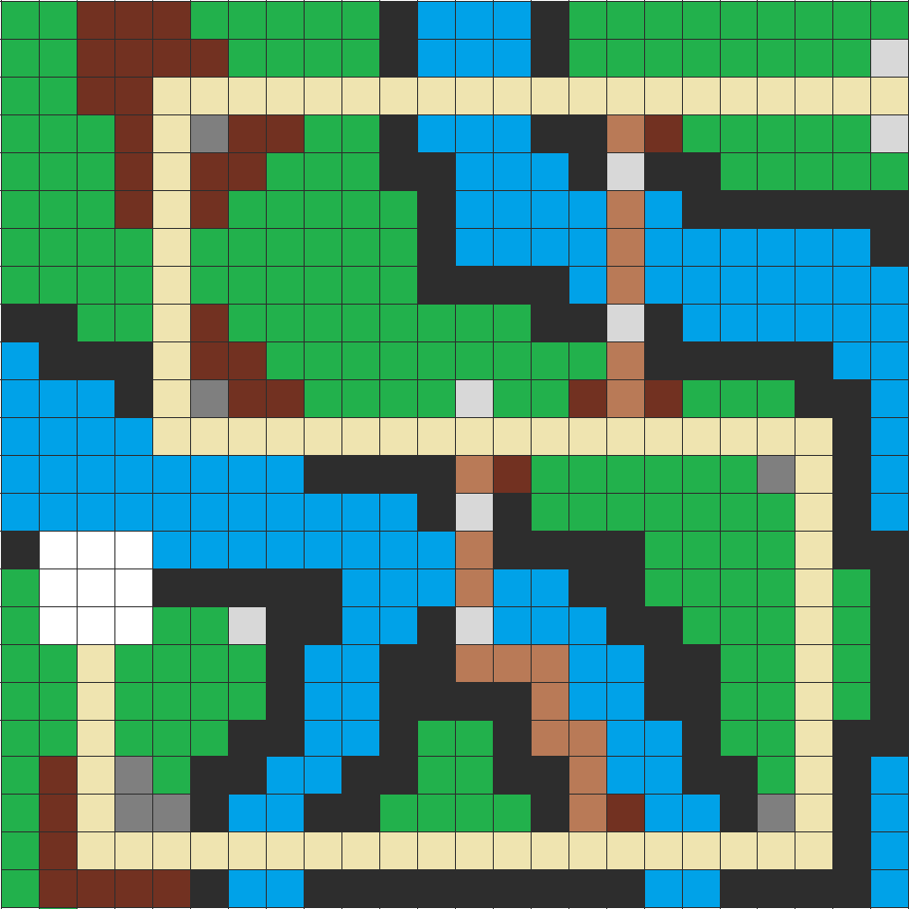

The above level is the first level to feature water and bridge mechanics. The player who’d rather not jump down the hazardous chasms (and probably can’t swim anyway) would rather walk over the bridges. Problem is, these bridges are the very same ones that the enemies take, making them hazardous to cross. Fortunately, there are alternate bridges blocked by resources that the player can open up. Even then, this opens up said path to the enemies as well.

**Towers**

Damage Types

There will two principle types of damage dealt by towers, focused damage and splash (area of effect) damage. Focused damage functions like a projectile, firing from a tower and striking one enemy for an amount of damage. The sniper’s projectile ignores armor. Splash damage attacks aim on a single enemy as well, but also deal damage to all other enemies within the radius or cone of attack. This makes it more effective on groups of enemies then a focused tower, while focused towers are better at picking off individual enemies, having more single-target power than splash towers.

Tower Range

The range of a tower is depicted by a transparent radius surrounding the tower when it is selected. All enemies within this radius will be potential targets for the towers to attack, with priority going to the first enemies who enter. Tower range can be expanded by upgrading a tower or by initially building it on higher ground. The range itself will be defined as a value in tiles, which the radius of the tower’s range will reach

Tower Types

These are the basic upgrade paths for towers. There are five main categories of towers, each fulfilling a specific role. Each of these towers also has two upgrades which increase their stats and abilities.

The first set of towers are the cheapest and most well-rounded. They are quick to build and take the least amount of resources. Their upgrade path increases their damage and range slightly.

Spear Hut

* Cost: 100 coins
* Build time: 2 seconds
* Range: 3 tiles
* Attack rate: 0.5 sec
* Damage: 100
* Cheap to upgrade
* Upgrades to **Watchtower**

Watchtower

* Cost: 160 coins, 10 wood
* Build time: 4 seconds
* Range: 3.5 tiles
* Attack rate: 0.4sec
* Damage: 115
* Upgrades to **Ballista Tower**

Ballista Tower

* Cost: 240 coins, 5 wood, 3 stone
* Build time: 6 seconds
* Range: 4 tiles
* Attack rate: 0.3 sec
* Damage: 135

The second set of towers feature splash damage. They are more expensive then the arrow towers but can do more potential damage. Their upgrade path increases the radius and damage of the splash effect and their effective range. They are especially effective against condensed groups of enemies.

Catapult

* Cost: 150 coins
* Build time: 3 seconds
* Range: 1.5 tiles
* Attack rate: 1 second
* Damage: 150
* Small splash radius
* Upgrades to **Cannon Tower**

Cannon Tower

* Cost: 225 coins, 3 stone
* Build time: 6 seconds
* Range: 2.25 tiles
* Attack rate: 1 second
* Damage: 200
* Medium splash radius
* Upgrades to **Siege Tower**

Siege Tower

* Cost: 300 coins, 5 stone, 3 iron
* Build time: 9 seconds
* Range: 3 tiles
* Attack rate: 0.9 sec
* Damage: 250
* High splash radius

The third set of towers are precision towers with very long range, high damage but low attack frequency. They are effective at picking off weakened enemies and dealing consistent damage to a single target for long periods of time. Their upgrade path further increases their range and damage and adds an armour piercing effect that lets them deal full damage to heavily armoured enemies.

Marksman Tower

* Cost: 200 coins, 5 wood
* Build time: 8 seconds
* Range: 5 tiles
* Attack rate: 1.5 seconds
* Damage: 300
* Upgrades to **Sharpshooter Tower**

Sharpshooter Tower

* Cost: 400 coins, 15 wood
* Build time: 12 seconds
* Range: 6 tiles
* Attack rate: 1.25 seconds
* Damage: 400
* Upgrades to **Sniper Tower**

Sniper Tower

* Cost: 800 coins, 10 stone, 5 iron
* Build time: 16 seconds
* Range: 7 tiles
* Attack rate: 1 second
* Damage: 500

The fourth set of towers are short-range streaming towers that fire in a cone at enemies, allowing several enemies to be hit at once within range. They are useful on corners, where there attacks can potentially hit the most enemies.

Burst Tower

* Cost: 175 coins, 3 wood
* Build time: 3 seconds
* Range: 1 tile
* Attack rate: constant
* Damage: 10
* AoE damage in a cone
* Upgrades to **Burst Tower 2**

Burst Tower 2

* Cost: 300 coins, 3 iron
* Build time: 5.5 seconds
* Range: 1.5 tiles
* Attack rate: constant
* Damage: 15
* AoE damage in a cone
* Upgrades to **Burst Tower 3**

Burst Tower 3

* Cost: 500 coins, 5 wood, 5 stone, 5 iron
* Build time: 8 seconds
* Range: 2 tiles
* Attack rate: constant
* Damage: 25
* AoE damage in a cone

The next tower group is a support tower, in that it does not directly damage the enemies. Instead, it fires area attacks that slow all enemies for a few seconds. Upgrades increase the range and attack rate slightly as well as the potency of the slowing effect.

Slow Tower 1

* Cost: 200 coins, 5 wood
* Build time: 4 seconds
* Range: 2 tiles
* Attack rate: 1.5 seconds
* Slows enemies in the area struck by the tower for 2 seconds by a factor of 30%.

Slow Tower 2

* Cost: 300 coins, 10 wood, 3 stone
* Build time: 6 seconds
* Range: 3 tiles
* Attack rate: 1.4 seconds
* Slows enemies in the area struck by the tower for 3 seconds by a factor of 40%.

Slow Tower 3

* Cost: 400 coins, 10 wood, 3 iron
* Build time: 8 seconds
* Range: 4 tiles
* Attack rate: 1.3 seconds
* Slows enemies in the area struck by the tower for 5 seconds by a factor of 50%.

With the introduction of day/night cycles, the player now needs to take into consideration the visibility of enemies from towers. At night, a tower’s range is only half of what it is at day, which is where these towers come into play. Seeing as these towers really require no man power, just a burning flame, they are free to build gold-wise. They will require a hefty amount of wood to burn though...

Lantern Tower

* Cost: 10 wood
* Build Time: 3 seconds
* Range: 2 tiles
* All enemies in range of this tower can be identified normally at night
* Upgrades to Torch Tower

Torch Tower

* Cost: 10 wood
* Build Time: 5 seconds
* Range: 3 tiles
* All enemies in range of this tower can be identified normally at night
* Upgrades to Bonfire Tower

Bonfire Tower

* Cost: 10 Wood, 3 iron
* Build Time: 7 seconds
* Range 4.5 tiles
* All enemies in range of this tower can be identified normally at night

While the sniper tower may provide a good answer to single armored enemies, there’s not much they can really do about crowd control. Fortunately, that’s where our next tower group comes in, the tesla tower, a tower that, while not high in damage, can electrocute enemies right through their armor. On top of that, it even chains between enemies, with longer chains with upgraded towers.

Spark Tower:

* Cost: 100 gold, 5 iron
* Build Time: 5 seconds
* Damage: 180
* Attack Rate: 1 second
* Range: 2
* Chains to 1 more enemy
* Pierces armor

Jolt Tower:

* Cost: 150 gold, 5 iron
* Build Time: 8 seconds
* Damage: 180
* Attack Rate: 0.75 seconds
* Range: 3
* Chains to 2 more enemies
* Pierces armor

Lightning Tower:

* Cost 200 gold, 3 stone, 5 iron
* Build Time: 12 seconds
* Damage: 180
* Attack Rate: 0.5 seconds
* Range: 3.5
* Chains to 4 more enemies
* Pierces armor

Despite having all these wonderful defences, enemies may still manage to bypass your defences and reach the village. That’s why, at the end of your path, you have your magic tower waiting, charging up to it’s maximum potential, waiting for an enemy to come into its sights. The magic tower, while remaining idle, charges its stores and unleashes a powerful attack. All subsequential attacks, though won’t be nearly as strong if the tower doesn’t manage to charge up.

Magic Tower 1:

* Cost: 150 gold, 1 wood, 1 stone, 1 iron
* Build Time: 6 seconds
* Base Damage: 100
* Charge Time: 20 seconds
* Peak Damage: 2000
* Attack rate: 1 second
* Range: 2 tiles

Magic Tower 2:

* Cost: 375 gold, 3 wood, 3 stone, 3 iron
* Build Time: 10 seconds
* Base Damage: 140
* Charge Time: 25 seconds
* Peak Damage: 3500
* Attack rate: 1 second
* Range: 2 tiles

Magic Tower:

* Cost: 625 gold, 7 wood, 7 stone, 7 iron
* Build Time: 16 seconds
* Base Damage: 200
* Charge Time: 30 seconds
* Peak Damage: 6000
* Attack rate: 1 second
* Range: 2 tiles

**Enemies**

Overview

The main opponents of the game, the enemies are a variety of unit types which will come at the player in waves each level, attempting to take away the villagers by walking along the path and leaving along it after reaching the village. There are several types of which the player must build a variety of tower types to counter successfully. They follow a set initial path in a given level, but should the player open a shorter path for them to travel they will take it instead.

Pathing

Enemies spawn along the edge of the map at the path, immediately beginning their journey to the player’s base. They will always take the shortest route there, which can influenced by the player’s collecting of resources along the path. However, they will not backtrack along a route should it be opened after they have passed it on their way to village or when leaving with a villager. However, if a shorter path is opened between the time they reach the village and when turning back to leave, they will take that path instead of their original one.

Enemy Types

There will be several enemy types found throughout the levels, with the most common being the standard soldier who has moderate health and speed, but low armour and no special traits. They make up the bulk of the enemy forces in the early levels and will carry one villager away if they reach the village. The second type of enemy is a scouting unit who has lower health and no armour but much higher speed. The third type is a large, slow enemy who is heavily armoured and has very high health. They are the only enemy type capable of carrying two villagers at once. The final type of enemy is a priest who is similar in stats to the soldier, but with more health and the ability to constantly heal enemies within a radius around him. Upon reaching the village he will not take a villager, but will still turn around and follow the rest of the enemies away.

**Note:** With the introduction of smooth pathfinding, these speeds become approximate.

Soldier

* Health: 4,000
* Speed: 1 tile per second
* Armour: 15%
* Carries 1 villager
* Coins: 20

Scout

* Health: 2,500
* Speed: 2 tiles per second
* Armour: none
* Carries 1 villager
* Coins: 30

Knight

* Health - 16,000
* Speed: 0.5 tiles per second
* Armour: 50%
* Carries 3 villagers
* On death, drops resources corresponding to what armor they were wearing.
* Coins: 400 + 1 iron resource

Priest

* Health: 5,000
* Speed: 1 tile per second
* Armour: none
* Carries no villagers
* Heals allies within a radius around them each second.
* Coins: 50

**Final Boss**

The final boss shows up at the very end of the second level. He will feature his own theme music as well as a special camera pan on entrance. Any villagers caught in his path are immediately killed instead of captured. Roughly every 20-40 seconds, the boss has a random chance of performing an attack that stuns all towers. The player will then need to return to these stunned towers to reinstate them.If the boss reaches the village, the game ends.

* Health: 50,000
* Speed: 0.85 tile per second
* Armour: none
* On death: Game win

Enemy Attributes

The major attributes that all enemies have are health, armour, movement speed and carrying capacity. Health is the amount of damage an enemy can take by towers before they are killed, while armour serves to reduce the damage of arrow attacks. Movement speed determines how fast an enemy moves along the path, while carrying capacity determines the number of villagers an enemy can take with them on their way out of the level.

**Resources**

Overview

One of the main components of the game, resources are used to construct and upgrade powerful towers as well as other structures like walls and for upgrading the player’s village. They are scattered throughout levels and must be harvested by the player before they can be used. Trees and rocks tend to crop up in commonly found areas, but the highly sought after iron usually takes a bit of journeying to get to.

Types

The primary types of resources are **coins**, **wood**, **stone** and **iron**. Coins are the base resource required to build all towers, and are obtained from defeating enemies. Wood is gathered from trees, stone is gathered from rocky outcrops and iron is gathered from iron veins. The rarity of the resources increases for each type, with wood being the most common and iron being the rarest. To fully harvest a resource, wood will take 2 seconds, stone will take 4 seconds and iron will take 8 seconds.

Uses

The primary use of resources is in the construction and upgrading of towers. Several towers can initially be built with just coins collected from defeated enemies, however any subsequent upgrades will require a resource investment. Tower strength is generally indicated by the type of resources used for its construction, for example a tower which requires wood will be inferior to one made of stone or iron.

Placement

Resources on a given level will generally be placed in such a way that the low-tier resources are easier and safer to collect than the high-tier ones. There is a much greater chance for wood to be located near the village in abundance then iron, which is normally found far away in minimal quantities as well as commonly in the middle of a path. Rarer resources also take longer to harvest than more common ones. Resource nodes may be several sizes, with larger nodes granting more of their respective resource.

**User Interface**

Overview

The UI will be as simple and clean as possible to stay in line with modern design standards. The majority of the screen will be occupied by the playing field, with context-sensitive menus appearing for things like building towers, upgrading towers and interacting with the village. The bottom bar of the UI will feature a simple bar with a wave progress meter on one side and the player’s resources along the other. Menus outside the main gameplay will be kept as simple and functional as possible, presenting a list options to the player for the given situation.

In-Game UI

The main focus of the ingame UI is in the centralization of almost all key UI elements at the bottom of the screen. Along the bottom will be found the wave progress bar to the left alongside pause, fast forward and skip buttons and the player’s resources will be listed to the right, with a small icon indicating each type. Menus for building towers will be context-sensitive, not appearing until the player clicks on a tile to interact with it. This will bring up a radial menu with the selection of towers on it, and a description of the tower when it is highlighted. Upgrading and selling will function similarly, with options for upgrading, selling and information about the tower. This menu will appear when the player selects a tile currently occupied by a tower. Finally, to view the range of an already-built tower, the player can hover their mouse icon over it, which will display a transparent circle that covers the area in which it can attack enemies.

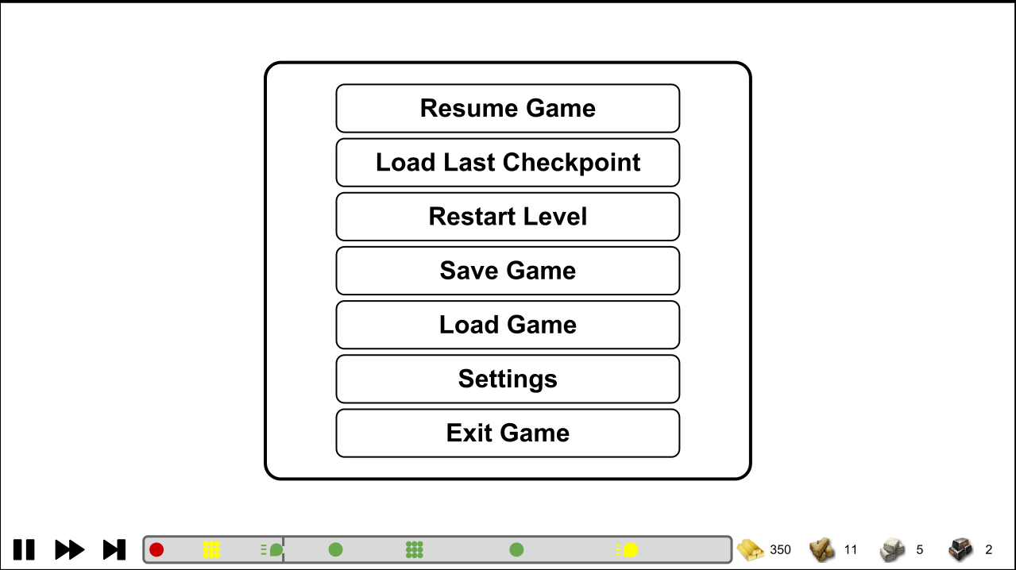

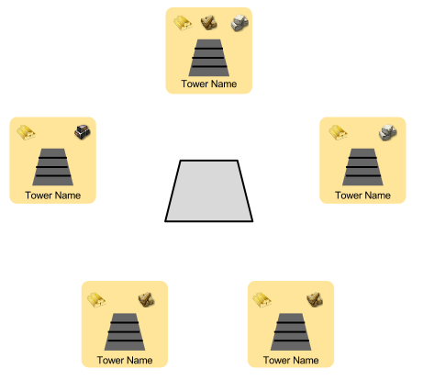

**Radial Menu When Selecting a Tile**

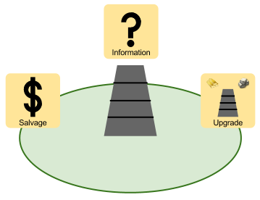

**Radial Menu When Selecting a Tower**

Progress Bar

The progress bar is a feature that allows the player to see the types of enemies upcoming for each round on a given level. They will appear as icons to denote their type, with the colour indicating the strength of the enemy, and will move from the right hand side of the bar where they initially appear to the left hand side, at which point they will disappear. At approximately 75% of the way to the right, there will a small bar to indicate that enemies have entered the level, at which point they will begin their movement on the path.

Pause Menu

When pausing during a game, the following options will be presented in a box in the center of the screen: resume, load from last checkpoint, save, load, restart level, settings, and quit game.

Main Menu

The main menu of the game will be relatively simple, with options to start a new game, load an existing game, view the available options and exiting to the desktop.

**Player Character**

Overview

The player character is the avatar the player controls within the game. They are responsible for harvesting resources, building towers and upgrading structures. They have a set of base stats related to attributes like tower building time, movement speed and harvesting time, which can be upgraded at the end of a level using earned experience points.

Customization

The player character's abilities can be improved through the perk system which features several selectable bonuses which can be unlocked by spending experience points at the end of a level. These bonuses are relatively small but permanent once unlocked and chosen.

Controls

Controls will be RTS-style click-to-move for the player character and building towers will function by approaching the tile to build on and clicking to bring up the tower menu. Resources will be harvested by simply clicking a valid resource tile, which the player will begin harvesting once they reach it. Because resources nodes contain multiple resources of their type, it is possible to order the character away should a situation come up elsewhere, having partially harvested the resource they were at.

Mouse and Keys

**Right click on map**: Moves player to that location

**Left click on map**: interact with tile

**Left click on incoming enemy bar**: Skip to next wave

**Esc**: Pause menu

**Space**: Fast forward

**Progression**

Overview

At the end of each round, the player earns experience which can be spent towards upgrading. The player can spend this experience on upgrade trees, and upgrade different aspects of their performance, such as how fast they build, to how efficiently they extract resources

Difficulty

Difficulty setting can be adjusted for each level, between Easy, Medium and Hard. Higher difficulties will increase the strength and armour of enemies, making them more difficult to kill.

Experience

Experience is earned only when completing or failing a level. If the player leaves early, then none is earned. Experience is affected by a few factors:

* The number of enemies killed and their type.
* The number of remaining villagers.

Upgrades

Upgrades are enhancements bought by the player that remain permanent for all following levels. They provide minor bonuses to how well the player performs their tasks, and provides minor enhancements to the towers themselves. They require a set amount of experience points for purchase. Upgrades include:

* How fast the player walks, builds, and harvests resources (separate upgrades)
* Bonus resources when harvesting a node
* Different aspects about the villagers you are protecting
  + Self Defence: Villagers will slap and punch any enemies that are holding them, slowing their movement by 5/15/25%.
  + Track and Field: Villagers, when dropped by killed enemies, will run faster back to the village, increasing their speed by 5/15/25%.